Table of Contents

1. PLANNING 2

1.1 OVERVIEW 2

1.2 AIMS AND OBJECTIVES 3

1.2.1 AIM 3

1.2.2 OBJECTIVES 3

1.3 PROBLEM IDENTIFICATION and STATEMENT 3

1.3.1 PROBLEM IDENTIFICATION 3

1.3.2 PROBLEM STATEMENT 3

1.4 OUR SOLUTION 3

1.5 DETAILED SYSTEM DESCRIPTION 4

1.5.1 SME’s CLIENTS 4

1.5.2 SME’s 4

1.5.3 ADMINISTRATOR 5

1.6 FUNCTIONAL REQUIREMENTS 5

1.7 NON-FUNCTIONAL REQUIREMENTS 6

2. FEASIBILITY STUDY 6

2.1 PROJECT DESCRIPTION 6

2.2 MARKET ANALYSIS 7

2.3 RISK ANALYSIS 7

2.3.1 Risks Identification 7

2.3.2 Control risks 8

2.3.3 SECURITY CONSIDERATIONS 8

2.3. REGIONAL CONSIDERATIONS 8

2.4 HARDWARE REQUIREMENTS 8

2.5 SOFTWARE REQUIREMENTS 9

2.6 PROJECT BUDGET 9

3. DESIGN 10

3.1 SYSTEM ARCHITECTURE 10

3.2 USE CASE DIAGRAMS 11

3.3 STORY BOARDS 12

3.4 UML CLASS DIAGRAM 13

3.5 USER MANUAL and Demo 13

3.6 SYSTEM SCREENS 13

3.7 Implementation Tools 14

4. Development 15

4.1 SOURCE CODE 15

4.2 RECOVERY PLAN 15

4.3 SECURITY 15

5. TESTING 16

5.1 TEST STRATEGY 16

5.2 TEST PLAN 16

6. DEPLOYMENT 17

6.1 DEPLOYMENT PLAN 17

7. FUTURE PLANNED FEATURE 17

# 1. PLANNING

## 1.1 OVERVIEW

SME’s are one of very important sectors in our economy however, they are also the most susceptible to fail particularly with regards to technology. Associated costs, technological change and a lack of IT acumen can have huge knock on effects for smaller businesses. Among others, these include manual & inefficient processes, unsuccessful marketing strategies, insufficient record keeping, limited access to data-derived insights for better decision making. As small businesses start to become medium businesses, or perhaps look toward improving their performance, they realise that the limited types of technology they once relied on are no longer adequate.

BSSR introduces a system, SMEs Anytime Strategic Analytics (SME ASA), which incorporates modern technologies to provide end to end architecture that covers particularly business intelligence and data analytics, customer relationship management, accounting, data storage and e-commerce.

For development of SMEs Anytime Strategic Analytics (SME ASA), team BSSR looked into problems faced by all SMEs that were interviewed but the main SME that the product is directed to is **Mr Ncube** of **CASA Investments**.

## 1.2 AIMS AND OBJECTIVES

### 1.2.1 AIM

The aim of the project is to develop a robust web application the is composed of an e-commerce and an organizational portal that will be able to meet the needs of the SMEs

### 1.2.2 OBJECTIVES

* To have a reliable record management system.
* To generate invoices, quotes, and receipts online.
* To aid financial reporting.
* To provide online service for selling of products online.
* To enhance decision making through business intelligence reporting.
* To provide integrated solution which require minimal IT skills to operate.

## 1.3 PROBLEM IDENTIFICATION and STATEMENT

### 1.3.1 PROBLEM IDENTIFICATION

* Manual records.
* Manual invoicing and quoting.
* Poor customer retention.
* Not able to track company performance.
* Poor financial and business reporting.
* Unsuccessful marketing strategies

### 1.3.2 PROBLEM STATEMENT

CASA Investments operation or processes are mostly done manually, from recording sales to recording purchases. As such this work becomes tedious and difficult to manage due to all the papers. The company finds it difficult to track customer retention and even find adequate solutions. They are not able to assess the performance of the company based of all the paper records they keep. Their customers need to bring their proof of purchase when they require a warranty for problematic products which because tedious to the customers themselves. The result of this is viewed as poor customer service. The solution we as team BSSR are proposing can easily solve all these problems.

## 1.4 OUR SOLUTION

BSSR introduces a system, SMEs Anytime Strategic Analytics(SME ASA), which incorporates modern technologies to provide end to end architecture that covers particularly business intelligence and data analytics, customer relationship management, accounting, data storage and e-commerce. This solution is based on automating the manual processes that SMEs uses and moving them to the use of smart modern technology of today bring them a step closer to being key players of the 4th Industrial Revolution (4IR).

## 1.5 DETAILED SYSTEM DESCRIPTION

The main idea of SME Anytime Strategic Analytics (SME ASA) is made in three parts with all the users having a unique role to play. The users of this system are the SMEs, the clients of the SMEs, and the administrator. For our system we made sure to have one entry point for all users. To access the system all users, need to login. Everyone will then be directed to the e-commerce where the SME Customers will remain and interact with the e-commerce site. To access the organizational portal SMEs and the administrator have to extend the URL with /index. To access the system the users need to have a username and a password if they do not posses these they either need to register or communicate with the system administrator.

Below are the details of what each user does on the system:

### 1.5.1 SME’s CLIENTS

The landing page of the system is the e-commerce site. To purchase any products or request for a service all users need to have an account on the system. In the event of the user wanting to purchase a product the user can either view the products on the home page or move to the categories where all the products the organization is selling are located and sorted. The user can either select the image of the product to view more details of the product before adding it to the cart or they can directly add the product to cart. When adding the product to cart the user needs to click the add to cart button, the product will be added automatically. The user can then either continue shopping or click on the shopping bag icon to see the products in the cart. If the user decided to view more about the product they simply click on the product image and then redirected to more information about the product. If they are satisfied they can click add to cart and the product will be added to the their cart, if they are not satisfied they can go back and continue shopping. In the cart the user can view all the products they have in the cart, they are liable to delete the products they have in the cart. If the users is satisfied they can then proceed to checkout. After clicking proceed to checkout the user will be redirected to enter their billing details and confirm their order. If they are satisfied they can now click on checkout where they will be prompted to enter their bank details to confirm the order. If the bank details meet the requirements the user will then be sent a receipt of purchases.

On the other side a user can request for a service. In this module the user will then be able to request for a service. The user will have to complete the form provided and submit it. All the users service request will be displayed on the dashboard. By clicking the action View on the dashboard the user will be redirected to another page showing more details of the service request. On the discussions & updates link the user can communicate with the SME.

Another feature on the system is the chatbot, if a user needs assistance with anything on the website they can simply ask the chatbot if the chatbot does not understand the request it will hand over to the organization to answer the question. After the user has achieved all the request, they can logout.

### 1.5.2 SME’s

Just like the SMEs customers the SME also need to login to the system if they have an account. But in this scenario all the accounts of the organization need to registered by the administrator. So if an organization employee does not have an account they cannot access the Organizational portal. The landing page for the organization is also the e-commerce site from here they will need to extend the URL to access the organizational portal. On the organizational portal SMEs and their employees can add their sales and purchases which will be stored on the data table link. They can also view the performance of the company using Analytics tab where different reports are provided. On the accounting tab the users are required to fill in the required forms in order to create the financial statements. Another module that users can interact with is the store feature. The users of the organizational portal can add products that will be displayed on the e-commerce site. They are also able to manage the products by deleting and changing pictures. The users can also communicate with their clients on the progress of the service they requested or on a question that the chatbot could not answer.

### 1.5.3 ADMINISTRATOR

The administrator is the user that is responsible of adding organizational users and assisting them with account creations and password changes.

## 1.6 FUNCTIONAL REQUIREMENTS

|  |  |
| --- | --- |
| **Customers** | |
| FR1 | Create accounts on e-commerce site |
| FR2 | Secure, Flexible Payments |
| FR3 | Get instance customer support via online chat system. |
| FR4 | Buy SME products online. |
| FR5 | Add products to cart |
| FR6 | View product categories |
| FR7 | Search for products using search function |
| FR8 | All products to have prices and product description |
| FR9 | Provide available shipping methods and prices |
| FR10 | Request a service |
| FR11 | Communicate with SMEs |

|  |  |
| --- | --- |
| **SMEs** | |
| FR1 | Allow login |
| FR2 | Allow logout |
| FR3 | Respond to any message sent by customers |
| FR4 | Record all customer purchases |
| FR6 | Produce invoices, quotes and receipts |
| FR7 | Access Analytical Dashboard |
| FR8 | Produce financial reports for the company |
| FR9 | Manage products |
| FR10 | Record Sales |
| FR11 | Change profile details |
| FR12 | Update and delete any records entered |
| FR13 | Manage Suppliers |

|  |  |
| --- | --- |
| **SYSTEM ADMINISTRATOR** | |
| FR1 | Should be able to add organization employees |
| FR2 | Assign system roles |
| FR3 | Should be able to remove user |
| FR4 | Should be able to change SMEs password upon request |
| FR5 | Allow login |
| FR6 | Allow logout |

## 1.7 NON-FUNCTIONAL REQUIREMENTS

|  |  |
| --- | --- |
| NFR 1 | Should be able to operate on various browsers |
| NFR 2 | Should be efficient enough to handle any capacity and have a response time of 5 seconds. |
| NFR 3 | Should be easy to navigate around even without training. |
| NFR 4 | Should be compatible with different screen size. |

# 2. FEASIBILITY STUDY

## 2.1 PROJECT DESCRIPTION

SME ASA is a web application that is in two-part, one part the e-commerce website the other is the organizational portal.

## 2.2 MARKET ANALYSIS

This product is very feasible in terms that it can easily be adapted by another SMEs. The only things that needed to be changed are the products and services that are offered. For this solution our target market is all SMEs that are looking to accommodate Business Intelligence or technological solutions as a whole into their companies. Our solution is one of a kind, this system is one that can be very much benefit the Information and Technology Industry. This solution can bring SMEs one step closer to being key players in the 4IR. The solution was built with consideration of SMEs, and their lack of technology maturity. Our competitive advantage with our solution is that we have built our solution using software architecture which helps SMEs take a giant leap into technology using existing approaches which can answer all their problems.

## 2.3 RISK ANALYSIS

### 2.3.1 Risks Identification

|  |  |
| --- | --- |
| **Risk identification** | **Risk Description** |
| **Injection Flaws** | This happens when malicious outside code masquerades as part of a command or query. The interpreter “recognizes” it and allows access to the software’s internal functions where it can bypass system boundaries, copy or manipulate data, and perform any number of unauthorized actions |
| **Sensitive Data Exposure** | This is how sensitive data is transmitted and stored. Protection of customer sensitive data is very import and if this data is made public it is punishable by the law. |
| **Broken Authentication** | This is the protection of Session IDs and Passwords. |
| **Broken Access Control** | This security risk is present in applications that do not properly verify roles and permissions. In other words, an attacker is able to access a web application resource by just knowing the URL. |
| **Lack of Technically Skilled Members** | Choosing the right team to develop the proposed solution is key |
| **Project Deadline not Met** | Not meeting the stipulated time if project completion |

2.3.2 Risks Assessment

**Exploitability**– How easy it is for a hacker to carry out the attack ***(1: Difficult to Exploit, 3 Easy to Exploit)***

**Ease of detection**– How difficult is it recognize a threat to this attack *vector* ***(1: Difficult to detect, 3 Easy to detect)***

**Likelihood of occurrence –** What are the chances of this risk occurring ***(0% Unlikely, 50% Either one, 100% Likely)***

**Impact–** How much havoc this attack can wreak ***(1: minor impact ,3: severe impact)***

|  |  |  |  |  |
| --- | --- | --- | --- | --- |
| **Risk** | **Exploitability** | **Ease of detection** | **Likelihood of occurrence** | **Impact** |
| **Injection Flaws** | 2 | 3 | 50% | 3 |
| **Sensitive Data Exposure** | 2 | 2 | 50% | 3 |
| **Broken Authentication** | 3 | 2 | 50% | 3 |
| **Broken Access Control** | 2 | 2 | 50% | 3 |
| **Lack of Technically Skilled Members** | - | - | 0% | 3 |
| **Project Deadline not Met** | - | - | 50% | 3 |

### 2.3.2 Control risks

|  |  |
| --- | --- |
| **Risk** | **Risk Control** |
| **Injection Flaws** | * The solution uses the appropriate functions and API to help sanitize data and increase security. |
| **Sensitive Data Exposure** | * Does not request unnecessary sensitive data. * Discard sensitive data after every 3 months. * Encrypt all data in transit, such as using https. |
| **Broken Authentication** | * Use of Flask Login to handle session protection. * Use of hashed passwords. |
| **Broken Access Control** | * Run integration tests to check that the user is redirected to the login page when trying to access to the given page without authentication. * Run tests for every Endpoint to check that it returns the correct error message if no or invalid credentials are provided. |
| **Lack of Technically Skilled Members** | * Find all suitable candidates to join the team well in advance |
| **Project Deadline not Met** | * Set up a clear schedule that needs to be followed by all team members |

## 2.3.3 SECURITY CONSIDERATIONS

All potential threats are mentioned above including the solution are mentioned above in the sections 2.3.1 and 2.3.2.

## 2.3. REGIONAL CONSIDERATIONS

The solution that is being proposed meets the data privacy laws of Botswana. Protection of user data was taken into consideration when creating the solution. All the customer data is set to be deleted every 3 months to avoid any malicious activity by hackers. Before any user enters any of their payment details they will be required to read through the privacy policy and terms and conditions of the system. Users are notified anytime they enter any private details.

## 2.4 HARDWARE REQUIREMENTS

* Processor: Minimum 1 GHz; Recommended 2GHz or more
* Ethernet connection (LAN) OR a wireless adapter (Wi-Fi)
* Hard Drive: Minimum 320 GB; Recommended 500 GB or more
* Memory (RAM): Minimum 2 GB; Recommended 4 GB or above
* Any size display screen

## 2.5 SOFTWARE REQUIREMENTS

* OS: Windows 7; Recommended: Windows 10
* Browser

# 3. DESIGN

## 3.1 SYSTEM ARCHITECTURE

## 3.2 USE CASE DIAGRAMS

Organizational Portal Use Case Diagram

E-commerce Website Use Case Diagram

## 3.3 STORY BOARDS

See GitHub

## 3.4 UML CLASS DIAGRAM

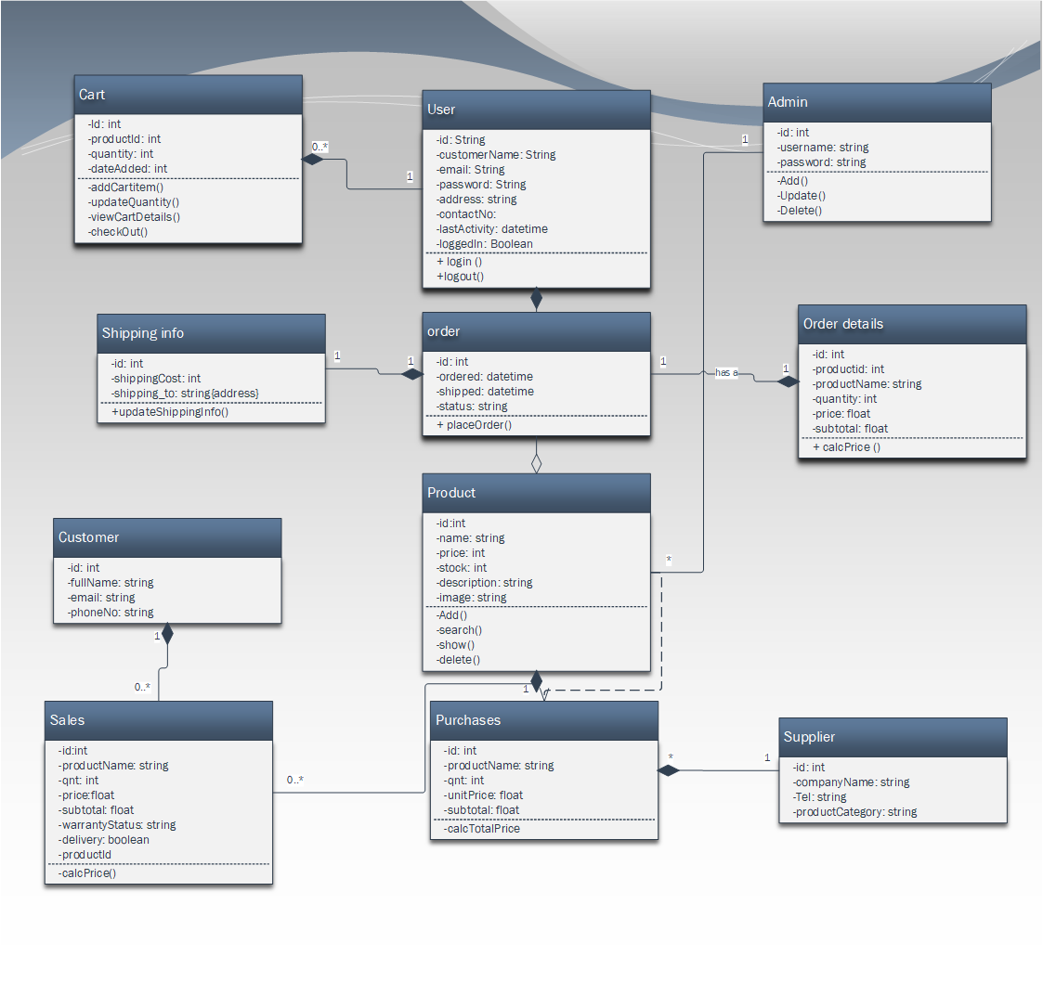

## 3.5 USER MANUAL and Demo

Seen images on the GitHub link below.

## 3.6 SYSTEM SCREENS

Seen images on the GitHub link below.

## 3.7 Implementation Tools

# 4. Development

## 4.1 SOURCE CODE

Seen images on the GitHub link below.

## 4.2 RECOVERY PLAN

The application database will be stored on the cloud in case of any malicious activity may take place. Another reason for a having a recovery plan is encase software failure or any unplanned hardware disaster. The recovery plan for our solution is to have the some of the database data being backed -up on a weekly-base on our personal server. But to back up this method we will be backing-up the database on pythonanywhere or any other hosting providers servers. This is to ensure that what every may arise we are able to get the system up and running in a short period of time.

## 4.3 SECURITY

To address the issues of security every user will generate their own password which they may change at any time. The user is to generate a password consisting on 8 characters which include only numbers and letters. When users sign-up or login to the application their passwords will be hidden with the use of asterisks. The system will operate on sessions which are set to 10 minutes per session per user. SME customers or employees that do don’t have an account on the system will not be able to access the organizational portal. Customers will not be able to purchase any products or services without the having an account.

# 5. TESTING

## 5.1 TEST STRATEGY

Software testing is the process of verifying if the developed output matches the requirements stipulated in the beginning of the project. This is to ensure the project is free from errors that may give the users trouble or make the software un useable. Testing is important because it guides the developer in finding errors or missing requirements the user had specified. The idea behind testing is to make sure the software is error free, reliability, secure and the performance is good. During this phase, the developer will be testing the functional requirements and non-requirements. The test approach used by the developer is Black Box Testing.

## 5.2 TEST PLAN

Testing of this software will be done using a Black Box testing technique called Usability Testing. Usability testing is the use of a group of representatives to test the software user interface. The idea behind this test is to find out whether the software is user-friendly if it is easy to learn and if users can easily navigate around the software. Usability testing is important because it helps the developer understand their users concerns and usability issues. With that it becomes easier for the developer to make changes easily based on the user’s input. The usability test will conduct on the functional requirements using a list of tasks for users.

The Usability test will be conducted using five representatives. The reason for this is because five users are able to determine 85% of the usability problems of the system unlike having a group of ten. A group of ten is more likely to spot 60% of the problems because most people would have identified the same issue. The usability test will be run with 1 users being moderated at a time by the developer. For the developer to get clear understand from the user the developer will only answer questions that do not giver the user the answer to complete the task.

The output of this task can determine whether the software is user-friendly or not. To fully

understand weather the software is used the developer looked into the usability measures.

* + How many tasks was the user able to complete correctly?
  + How long did the user take to complete the tasks?
  + From the number of users how many completed the tasks without help or any errors?
  + Identifying the difficult tasks based on though that were not answered or were not, correct?
  + How the users felt about the software?

# 6. DEPLOYMENT

## 6.1 DEPLOYMENT PLAN

Seen images on the GitHub link below.

# 7. FUTURE PLANNED FEATURE

The idea is to expand our solution in future. There are some key feature we are looking forward to implementing for example a **desktop application**. This desktop application will not be of the whole solution but of the Organizational portal alone. This is to make it easier for SMEs that do not have internet regularly. SMEs using the desktop app will be able to record all their sales and purchases. Another key feature we look to develop in future is a **mobile application** of the solution. This feature will be resources for the SMEs when they are on the move and do not have their laptops.